

**The Climber**

**Thanks for downloading the asset. If you have any questions or queries, please contact me at** [**ridealone3215@gmail.com**](mailto:ridealone3215@gmail.com)

**Project Structure**

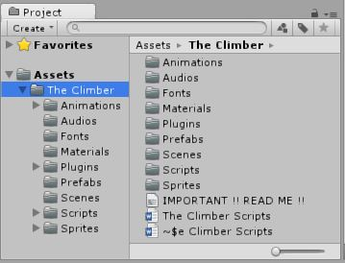

**Animations folder:** All animations used in the game are stored in this folder.

**Audio folder:** All game audios are stored in this folder.

**Materials folder:** All material components of the gameobjects in the game are stored in this folder.

**Prefabs folder:** Prefabs used in the game are stored in this folder.

**Scenes folder:** All the scenes used in the game are stored in this folder.

**Scripts folder:** All the game related scripts are stored in this folder.

**Sprites folder:** Sprites folder has the images used as game backgrounds, GUI images, in-game elements, platform sprites, zombie sprites etc. used in the game.

**Scripts**

1. **Background Moving Script:** This script handles the movement of the background sky.

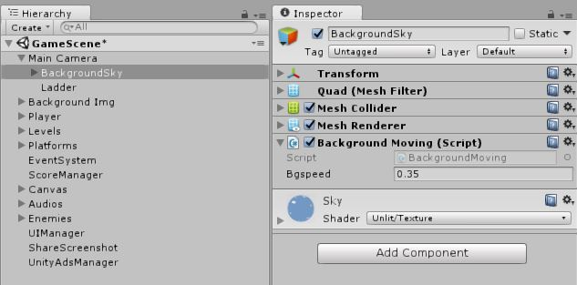

1. **Camera Controller Script:** The camera movement is controlled by this script

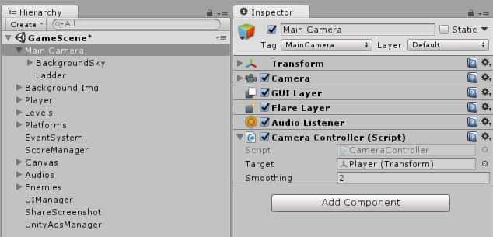

1. **Enemy Movement Controller:** The enemy movements are controlled by this script such as speed etc.

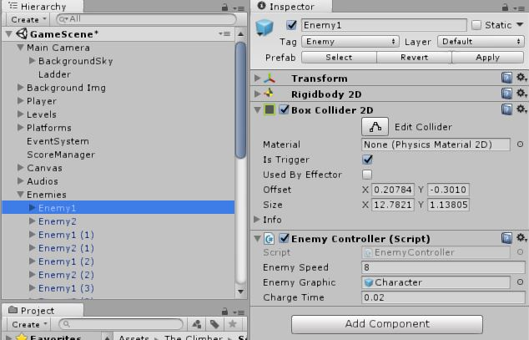

1. **Enemy Damage Script:** The player dies when he touches the enemy. This action is done by this script. Also, coin is dropped by the enemy using this script.

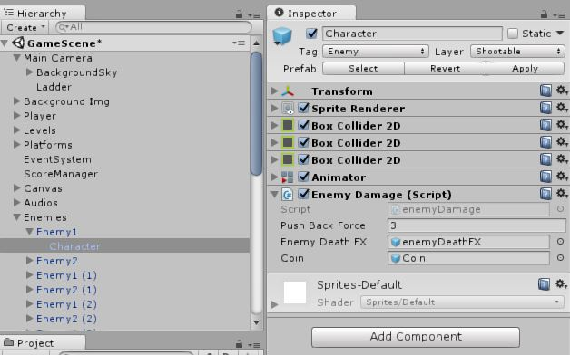

1. **Moving Platform Script:** The movements of the moving platforms in the game is controlled by this script.

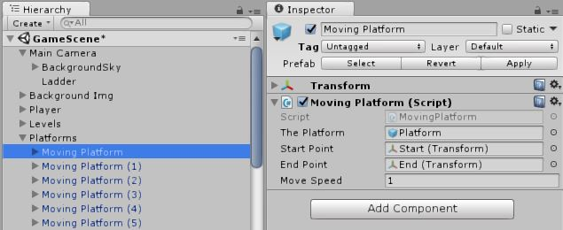

1. **Platform Collision Script:** This script allows the player to pass through the platform when he jumps from downside on to it.

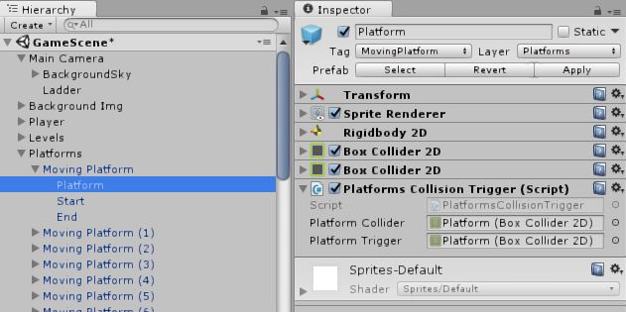

1. **Player Controller:** This script controls all movements of the player.

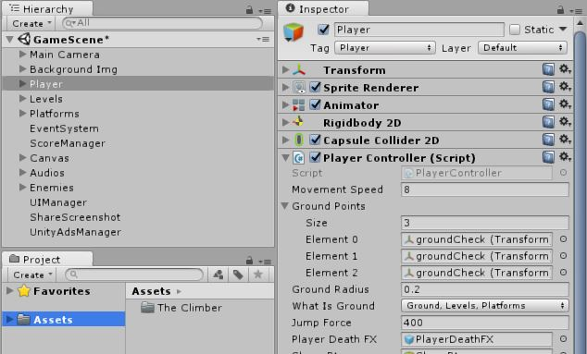

1. **Points Adder:** This script is attached to the coin prefab in the game. It adds points in the score.

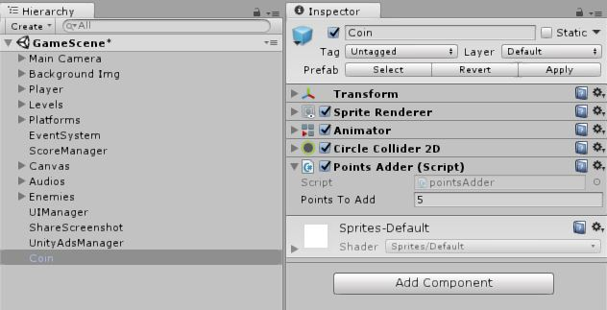

1. **Score Manager:** This script keeps record of points and best points in the game.

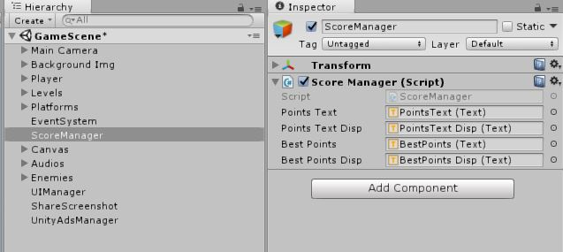

1. **Share Screenshot:** This script helps to take screenshot of the high score (best points) and share it on WhatsApp, Facebook, etc.

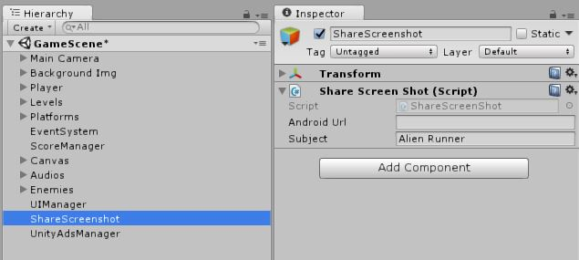

1. **UI Manager:** This script is used to control UI Buttons.

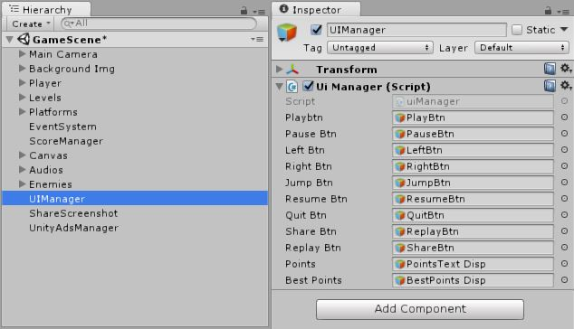

1. **Unity Ads Manager:** This script is used to show ads within the game.

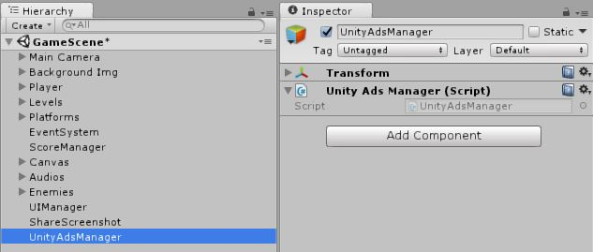

**THANK YOU ☺**

**Please rate my asset. I would appreciate it.**

**Subscribe to my Channel for More Free Assets and Updates.**

[**Dinesh Nalhe**](https://www.youtube.com/channel/UCznJyk5Pwvvm61rWyAirk9w)